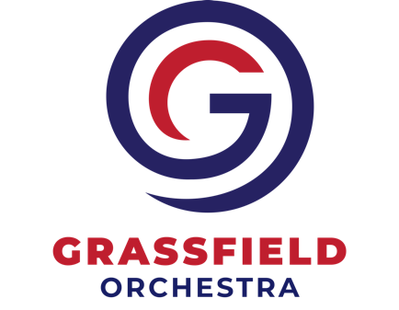
NEW MEMBER ENROLLMENT FORM
Grassfield Orchestra Parent Association (GOPA) RaiseRight (SCRIP) Program

Program guidelines

- Orders must be placed, along with payments, through https://www.raiseright.com/
- All orders must be paid online using PrestoPay
- Upon request, GOPA will provide a summary of each participating family’s RaiseRight purchases. Summary reports are also available online through raiseright.com.
- RaiseRight cards are purchased on your behalf and are not returnable
- You must submit a Rebate Summary Form annually by the due date on the form or your RaiseRight (SCRIP) Account will be disabled and your Grizzly Dollars will be donated to the Orchestra Program. This form directs GOPA how to handle your rebates – Grizzly Dollars to be used for your student’s orchesatra fees, donation to GOPA, donation to another student, or refund to you. This form must be re-submitted ANNUALLY.
- You may allow family members to enroll in the GOPA RaiseRight program on behalf of your student. Before family members may be enrolled, you must actively participate in RaiseRight by placing at least 8 orders (to ensure that you understand how the program works.) Family members must fill out and submit all enrollment and annual rebate forms to GOPA before enrollment. Should a Presto Pay order be returned for non-sufficient funds, please note that the ORCHESTRA PARENT will be responsible for settling fees with GOPA.

Your First Name | Your Last Name
Student’s First and Last Name: | Student’s Grad Year: | Instrument
Street Address |  | Your cell phone:
City | Zip | Alternate phone
Email

I have read and understand the program guidelines described above, and I agree to abide by these guidelines.
________________________________________________________________________________________________
Signature Date

