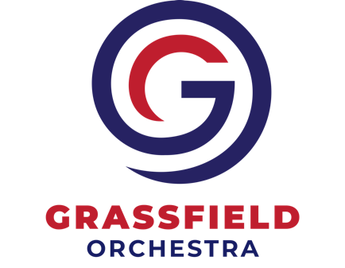
Grassfield Orchestra Parent Association, Inc.
RaiseRight Rebate Form for Orchestra 2022-2023
(June 2022-May 2023)
*** A new form is required EACH YEAR ***
=============================================================================================================
RaiseRight Account Holder’s Name: _______________________________ Date: ___________
Purpose of Submission: (circle one)
New Member Request Rebate* Update Deactivate/Close Account
* $________Total Requested or ____ All Grizzly $$ Available
Please apply my rebate in the following ways: (select one):
____Credit my rebate to my student’s Grizzly Account.
Name of student(s): ________________________________________________________________
____ Credit my rebate to the following orchestra student: _________________________________________
____ Credit my rebate as a charitable contribution to the GOPA(tax deductible, see below)
=============================================================================================================
Grassfield Orchestra Parent Association, Inc. (GOPA, referred to herein as “we”, “us”, and “our”) sponsors a RaiseRight (previously known as SCRIP) program which allows you to purchase RaiseRight gift/shopping cards. The RaiseRight cards you purchase through our program generate rebates from participating retailers. These rebates can be used as a credit to your orchestra student’s account, a gift to the orchestra program, or a gift to another orchestra student’s account. Rebates credited to your orchestra student’s account are intended to help pay for your student’s orchestra participation fees though all rebate funds are yours and will be paid to you as described below. All Rebates funds are held in a separate bank account for RaiseRight use only.
New participants may enroll at any time by completing enrollment forms, which include this form. Returning families who have participated in RaiseRight previously must renew annually to continue to participate in the RaiseRight program in the coming orchestra year. Senior student accounts will be closed on May 25th of their graduating year unless a new RaiseRight rebate form (this form) is completed, designating a sibling, another orchestra student, or GOPA as the recipient of rebate funds. All forms whether Returning student or Senior student must be returned to the GOPA RaiseRight Coordinator by May 31st of each year. Failure to do so will deactivate your RaiseRight account and your Grizzly Dollars will be donated to the GOPA.
Note: families of graduates may continue to participate in RaiseRight but may only donate to the GOPA or to another orchestra student; rebates will not be refunded. If you choose to donate your rebate to the GOPA, we will provide you with all required acknowledgements under sections 170(t)(8) and 170(t)(17) of the Internal Revenue Code.
Our RaiseRight program distributes the rebates to Grizzly Dollars monthly as you have selected above. Participants may request a check for the balance of funds in the student’s Grizzly account annually, or upon special request (not more than quarterly.)
You agree to indemnify us against any loss incurred in connection with there being insufficient funds in your account to cover the checks or ACH transfers you issue to pay for your RaiseRight. We make no representations or warranties of any kind with respect to RaiseRight. This agreement continues unless replaced by another, and can be terminated by either of us upon 60 days advance notice to the other.
Please sign and date to indicate your acknowledgement of this agreement:
Member’s Signature: ____________________________________________ Date: _________________
=============================================================================================================

Internal Use: Grassfield Orchestra Parent Association, Inc.

Account updated within RaiseRight program and the GOPA Accounting System to reflect rebate choices above.

By: ______________________________________________ (GOPA RaiseRight Chair) Date: ______________

By: _______________________________________________ (GOPA Treasurer) Date: ________________

Check # for Rebate: ______ Check Amount: _______ Date: ________ Remaining SCRIP balance: _________

CUTTIME Updated: ________________

